# Exercise: Cubicle

Problems for exercises and homework for the ["Node.js & Express.js Fundamentals" course @ SoftUni](https://softuni.bg/courses/express-js-fundamentals)

## Initial Setup

### Install dependencies

Run **'npm install'** to install all the dependencies.

## Create Schema and Model

### Create Cube Schema

Each cube should have the following properties:

* **Name** – string (between **3** and **15 characters**)
* **Description** – string (between **20 and 300 characters**)
* **Image URL** – string (should start with https:// and end with **".jpg**" or **".png"**)
* **Difficulty** – number between **1 and 6**

### Create Cube Model

## Create Routes

You should implement the following routes:

* **/** - the main page (should visualize all the cubes in the database and a search field)
* **/about** – should render the about page
* **/create** – should render the create cube form
* **/details/:id** – should render the details page about selected cube

### Main Page

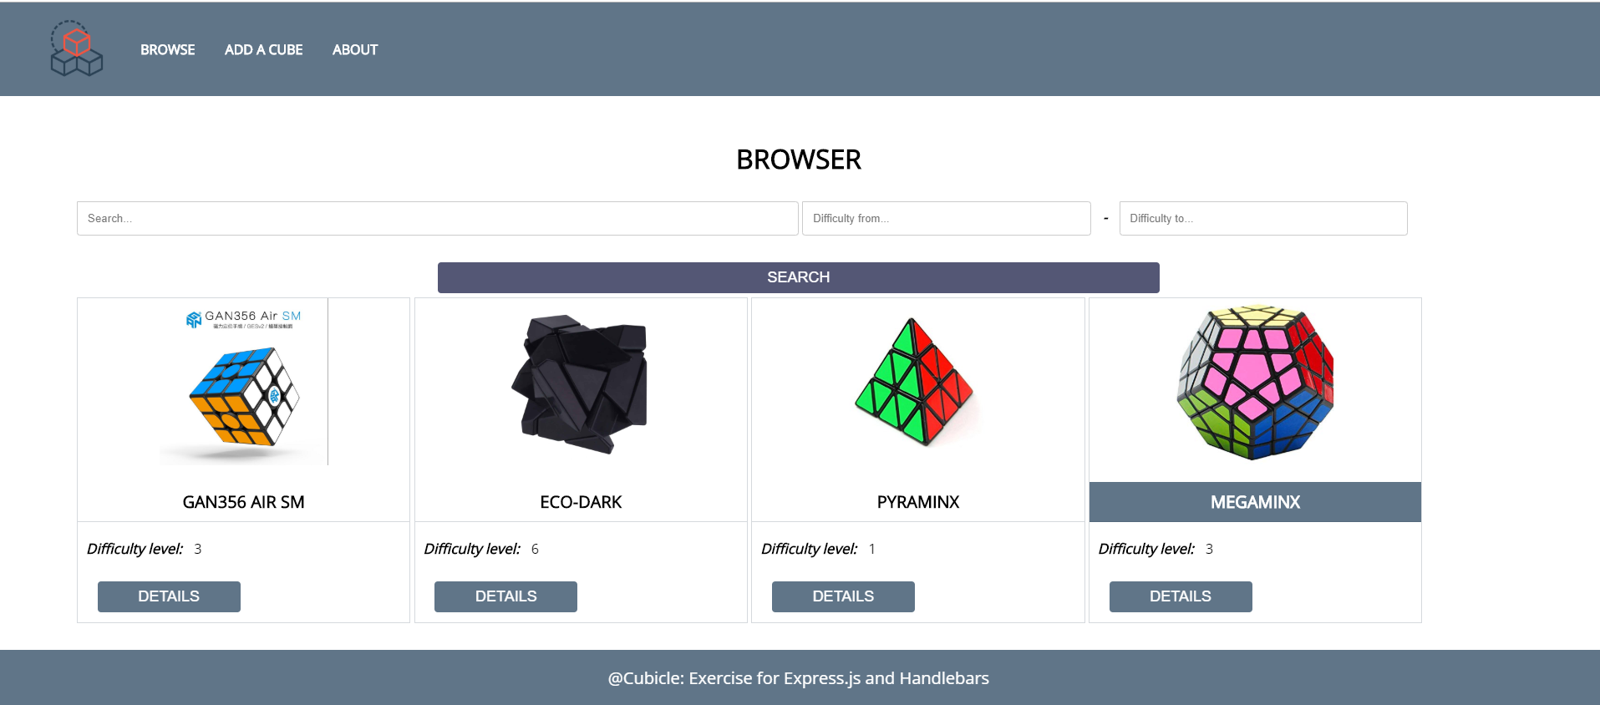

### About Page

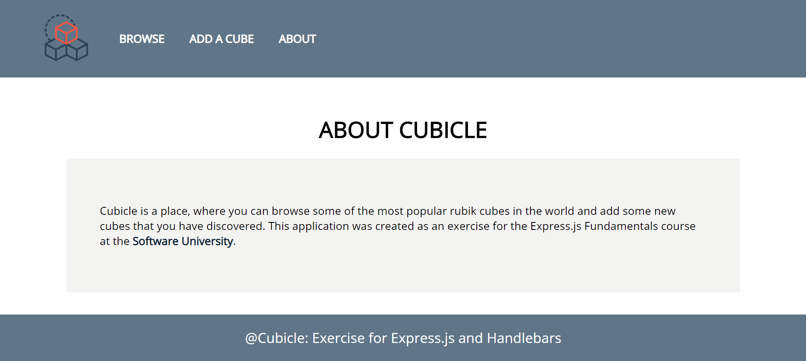

### Create Page

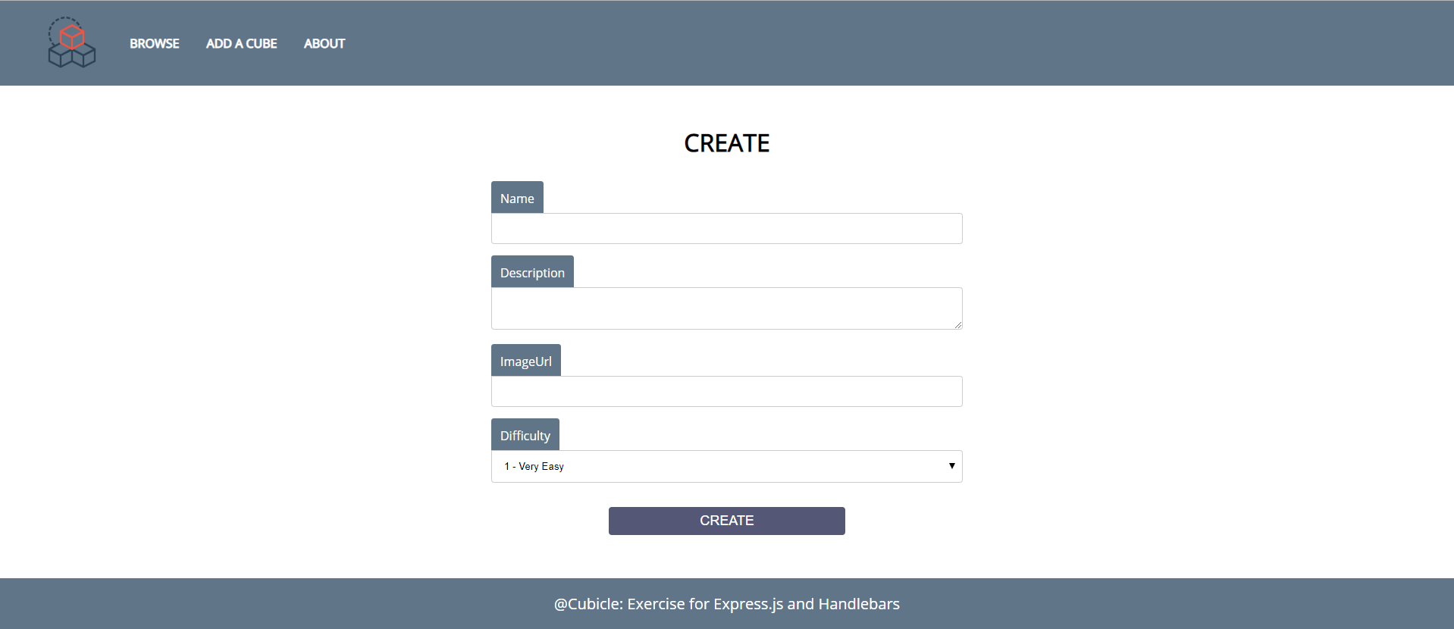

### Details Page

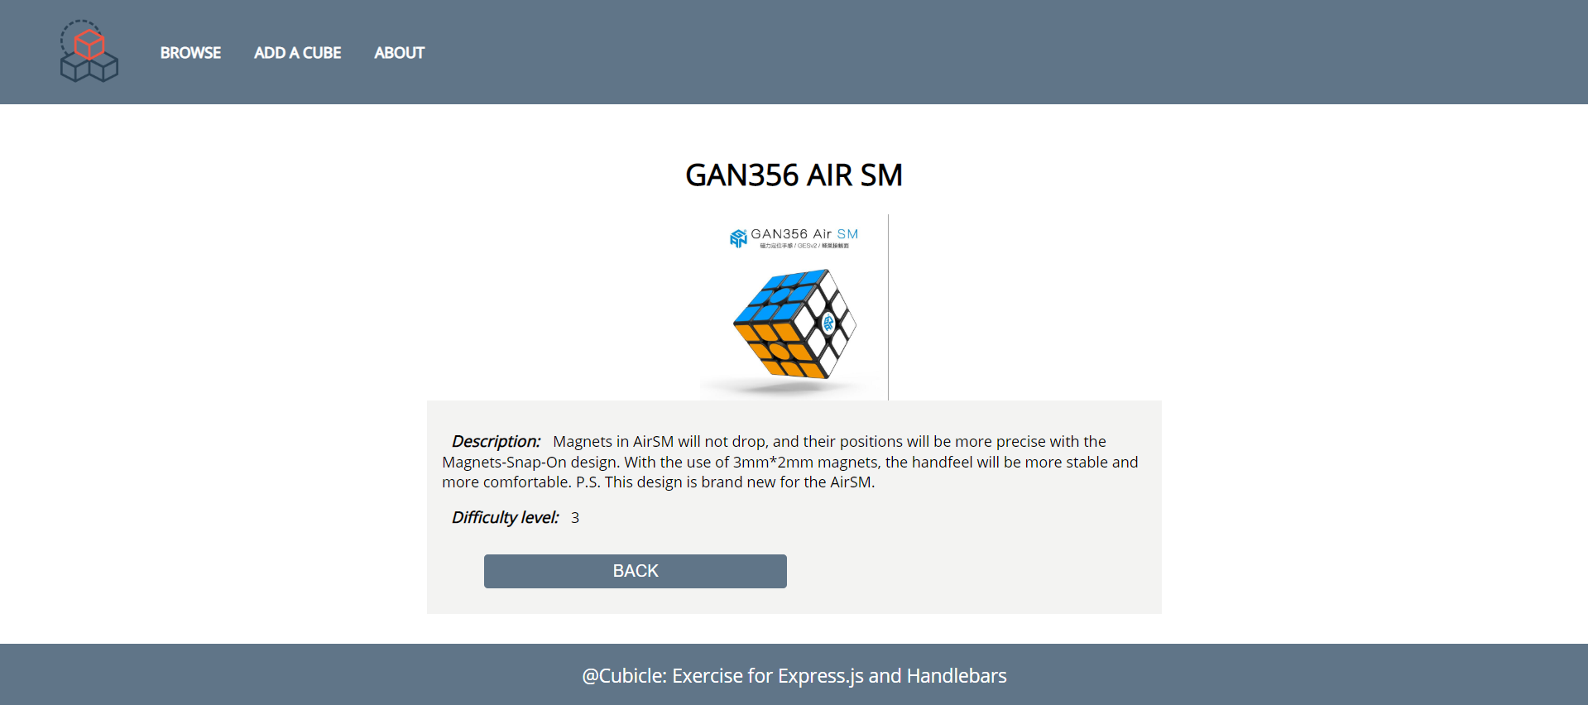

## Create Templates

Use the provided HTML to create templates with a format that is supported by your view engine. Identify the dynamic parts and use appropriate syntax for interpolating and rendering the application context.

#### Render Templates

Implement template interpolation and rendering with the appropriate context in all handlers.

## Search

Implement searching logic. Use the following validations:

* If the user searches **only** a particular **string** and **NO difficulty**, render **all difficulties**
* The difficulty inputs must contain only **numbers between 1 and 6**

If the search does ***NOT*** meet the requirements, send **error message** to the browser. More information in the next step

## Error Notifications

When there is an error in any of the forms (create or search) you should stay on the **same page** and **display error notification**.

### 6.1 Create Form Errors

* Name: **'Name must be between 3 and 15 symbols!'**
* Description: **'Description must be between 20 and 300 symbols'**
* Image URL: **'Image URL must start with https://'** or **'Image URL must end with .jpg or .png'**